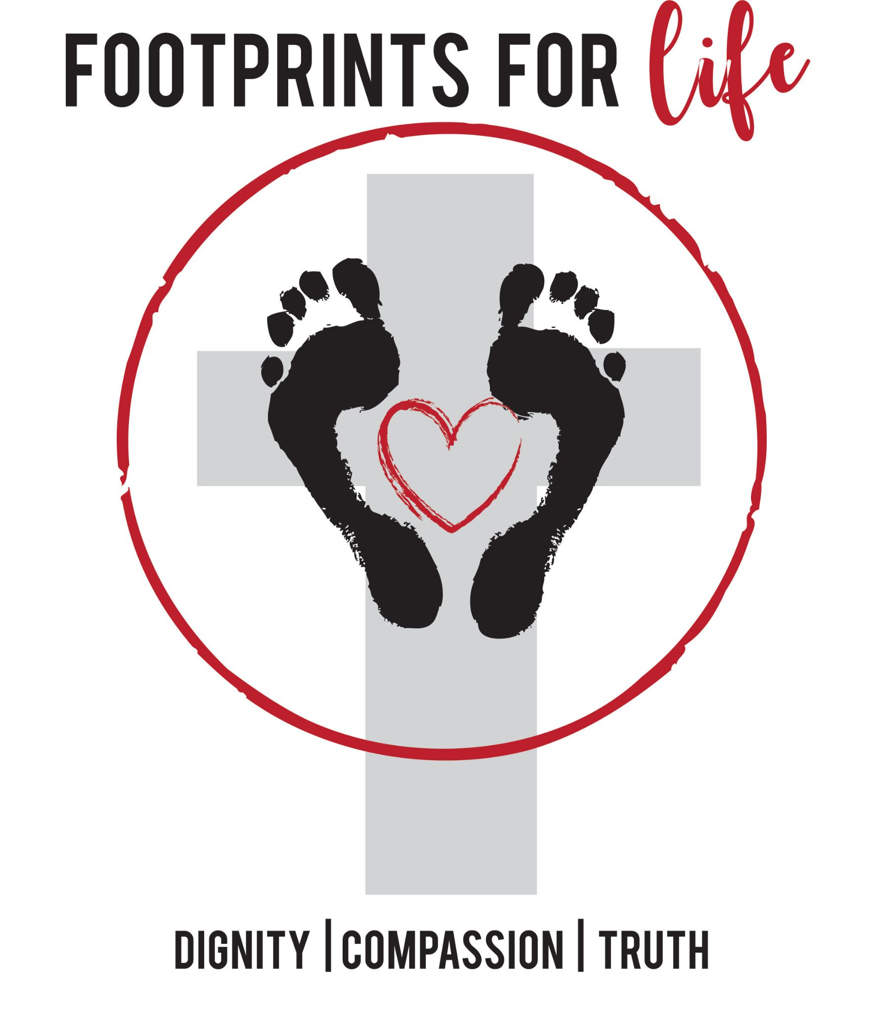
Footprints for Life
“ Cultivating a Culture of Life in Our Children”

Dear Parents,

We are excited to announce that we will be using the “Footprints for Life” Program as a supplement in our 4-th -7th grade Religion classes.
This program is designed to cultivate a Culture of Life in our children. The program builds on a foundation of dignity, compassion, and truth. The program covers USCCB Culture of Life topics age-appropriately, and incorporates discussions, activities, and the Spiritual and Corporal Works of Mercy into the study of these issues.

We believe it is important that we teach our children to love & respect others – regardless of race, beliefs, abilities, etc. Also, children need to know that they CAN make a difference, even with the smallest of actions. By teaching our children to pray for, respect, and support those in need, we raise children that stand for what they believe in and, most importantly, come to know that God will provide. The children of today have a passion for protecting life…they just need a path.

You can find additional information about the program at ChoosetheChild.com Also, if you have any questions about the program, please feel free to contact Moderator Name and Phone Number.

“Train up a child in the way he should go; even when he is old he will not depart from it.” Proverbs 22:6
