T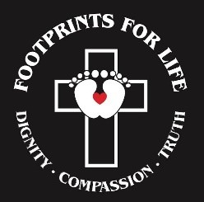
Footprints for Life

The “Footprints for Life” t-shirts are available to everyone – children and adults! The “Footprints for Life” Program is now used as supplemental material in the Archdiocese of New Orleans and is expanding! This life-saving program can also be used at home or in any setting for children.
Our children are the footprints of the future and together we can
educate and empower them to Change the Culture!

Each t-shirt order supports the Respect Life Movement and
the education of our children!
The School Name students can wear these t-shirts on any days that “School Name t-shirts” are allowed.
You can also visit ChoosetheChild.com for more information on raising our children to change the culture.
Moderator Name Moderator Email Moderator Phone Number
--------------------------------------------------------------
If you would like to order a t-shirt, please send this form with your
check made payable to School Name by Date
You can send it to Moderator Name.
Child’s Name_____________________________________ Homeroom______
T-Shirts:
YS _____ YM_____ YL_____ AS_____ AM_____ AL_____ AXL_____
1 Shirt - $15 2 Shirts - $27 3 Shirts - $40
Total Number of Shirts: _____ Total Amount Enclosed:_______
T-shirts CAN’T be ordered without payment.

